Summary English of the WECF publication (Dutch):

Veel bestrijdingsmiddelen in beken en kanalen -
Feiten over bestrijdingsmiddelen in het oppervlaktewater in Drenthe

Too many pesticides in ditches and canals
Facts on pesticides in surface waters in
the Dutch province Drenthe

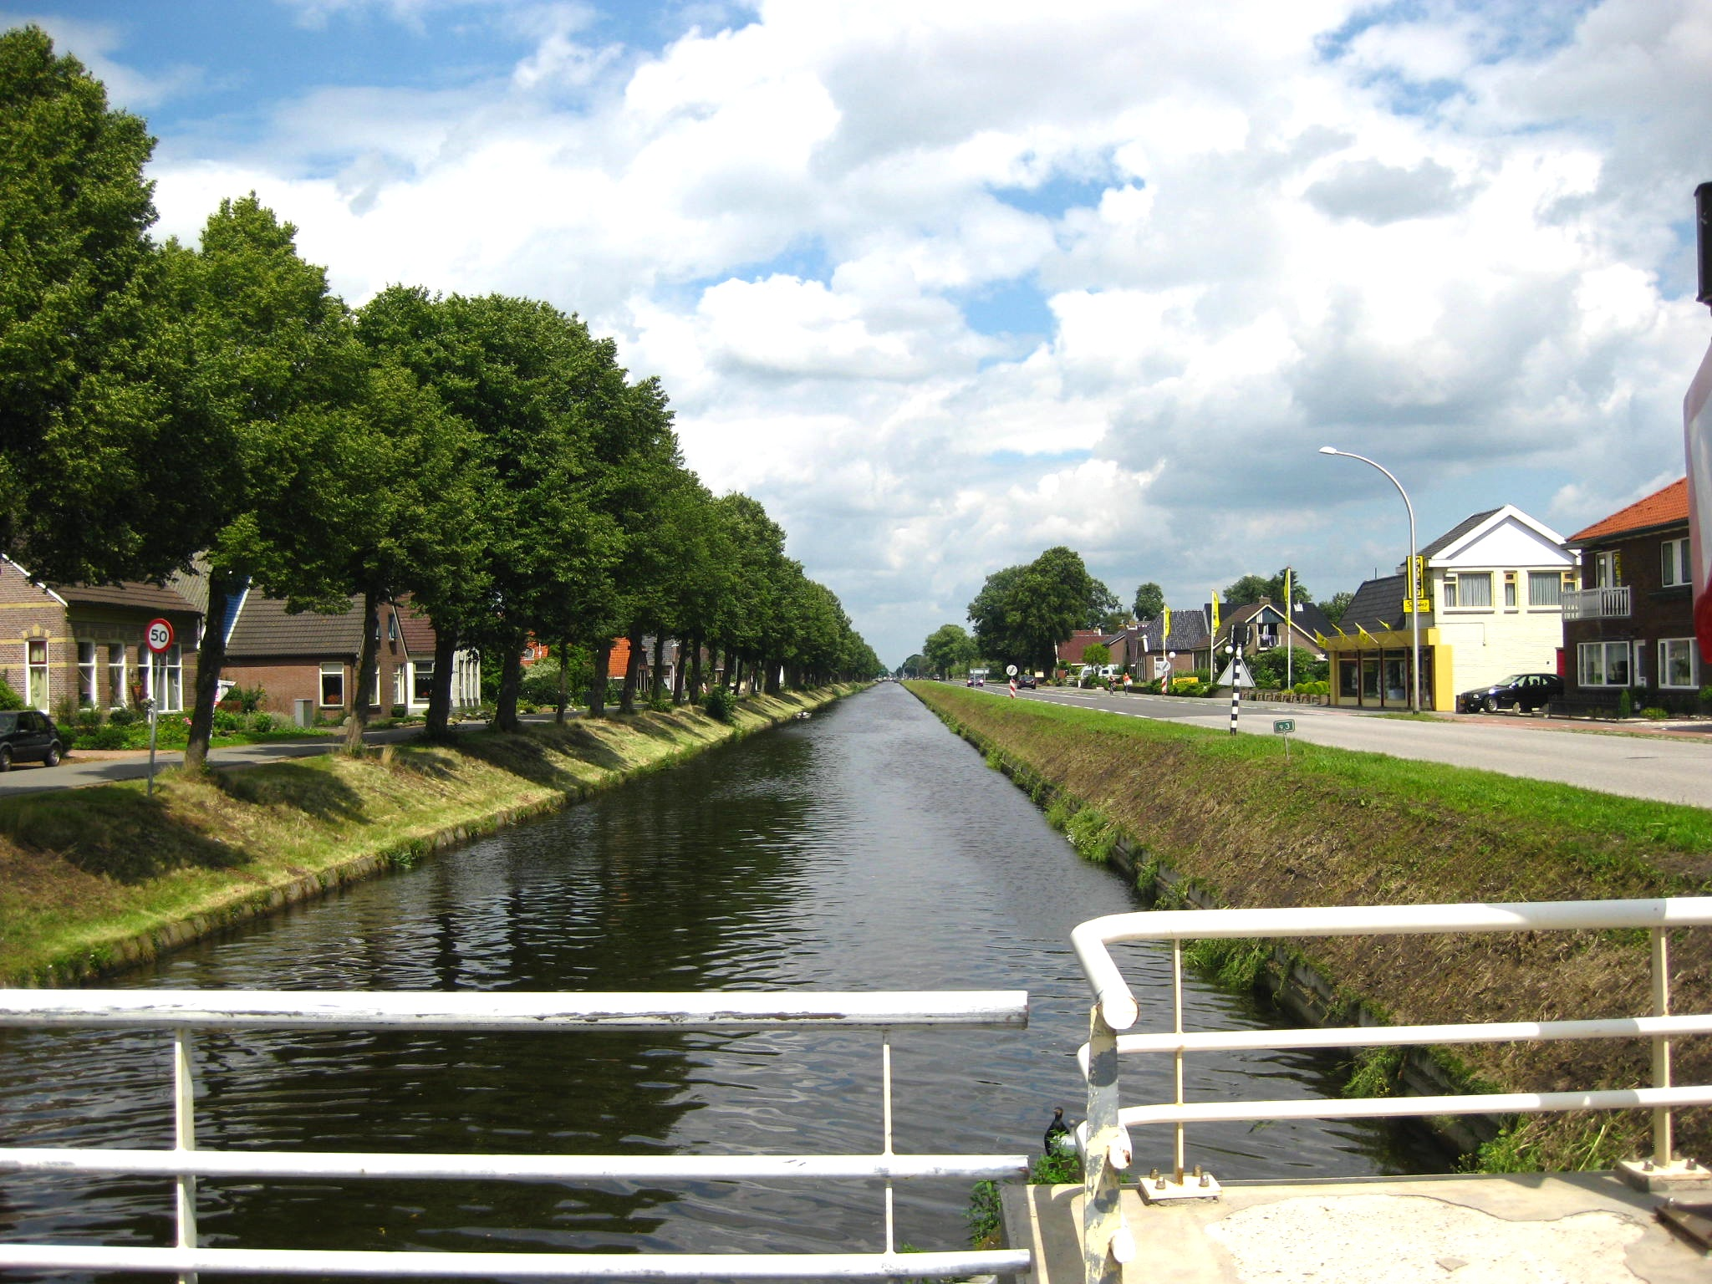

Background
The Netherlands is one of the countries that accepted the Sustainable Development Goals (SDGs) in 2015: Although the Netherlands reached already several (sub) goals such as ending extreme poverty (SDG2), still there are goals where the country has to focus on. All inhabitants of the Netherlands have access to clean drinking water and safe sanitation. However due to the intensive agricultural practices many surface waters are contaminated with hazardous chemicals (SDG 6), ecosystems are out of balance and the biodiversity is decreasing (SDG15) and a sustainable consumption and production of food should be improved (SDG 12).
The Dutch river basins of the Rhine, Meuse, Schelde and Ems are annually monitored on contamination with pesticides. Depending on the local agricultural activities and the possible impact on the environment certain active substances, metabolites and sampling points for rivers, ditches and canals are selected and analysed.
In general the sampling is conducted 4 times a year and the samples are checked on 30 up to 100 pesticides or even more. Comprehensive information about the monitoring locations, the analysed substances are published by the Dutch Ministry in the Bestrijdingsmiddelen Atlas (Pesticide Atlas) (www.bestrijdingsmiddelenatlas.nl).
In general, it is well known that in the Western part of the Netherlands - the region with intensive greenhouse and flower cultivation – surface waters are seriously contaminated with pesticides originating from those activities. However, this publication focuses on the less known pesticide contamination of surface waters - belonging to the river basins Rhine and Ems - in the Northern province Drenthe.
Drenthe - with an area of 2,683 km² - is a touristic province with several protected nature areas. In spite of its vulnerable sandy soils, the cultivation of flower bulbs and vegetables in greenhouses has been a fast growing branch in Drenthe the past 15 years. Furthermore, an intensive cultivation of corn and potatoes is practiced.
Margriet Samwel-Mantingh (WECF senior advisor Water and Food Safety), the author of the publication “Veel bestrijdingsmiddelen in beken en kanalen” assessed information from the Bestrijdingsmiddelen Atlas, from relevant websites and the pesticide database from Pesticide Action Network (PAN), publications related to the environmental impact of pesticides, the cost/benefits of pesticides, implemented and on-going pesticide reduction programs and reports. The presented facts related to the pesticide contamination of surface waters in the Province Drenthe refers to almost 90 literature and website citations and was reviewed by three scientists/ environmental consultants.
The report was published in Dutch in March 2017) and is downloadable at: http://www.wecf.eu/download/2017/03- March/20170323Oppervlaktewatervervuilingindrenthe_fin.pdf

Summary of the presence of pesticides in surface waters in the province Drenthe (in 2014):
• 236 active substances and metabolites and 28 locations were included in the pesticide-monitoring program (2014).
• Not all substances were monitored equally in the selected monitoring locations: 48 active substances (20%) were monitored seasonally in all selected locations; the other 188 substances were monitored in 6-8 locations.
• In the 28 monitored locations, 379 times residues of pesticides and metabolites were found; on average 14 pesticides and metabolites were identified in one location.
• Drenthe has some “hot-spots” (mainly regions with lilies, flower bulbs, vegetables and greenhouses) where in ditches and canals 20-40 different pesticides were identified;
• 10% to 20% of the detected pesticides exceeded the established norms (maximal acceptable concentration (MAC) or the annual average of the MAC)
• Among the 74 different identified pesticides (active substances) were 28 herbicides, 19 insecticides and 28 fungicides. Some substances were multi-functional. In addition, 5 different metabolites – with unknown activity - were found.
• According to the PAN List of Highly Hazardous Pesticides (December 2016) half of the 74 different found active substances are classified as highly hazardous.
• For many active substances information is lacking for an adequate assessment of the potential hazards to health and environment.
• There is a severe lack of knowledge on the impact of “Pesticide Cocktails” and pesticide metabolites on health and environment.
• The pesticide norms (Maximum Acceptable Concentration (MAC)) and the average annual MAC for surface water provides little insight about the actual risks; a substance can be listed in the PAN “List of Highly Dangerous Pesticides”, while the norm takes the toxicity of the substance insufficiency into account.
• The analytical capabilities of laboratories are often insufficient to identify the presence of an active substance in surface water. The analytical capability was lacking for about one quarter of the substances included in the monitoring program. Thus, for the concerned pesticides, the presence in surface water cannot be assessed. Or in case of exceeding the norm some times only partially.
• Taking into account that many pesticides were not or only partly measurable, the found substances are just a part of the real pesticide contamination of the surface waters in Drenthe.

“Highly Hazardous Pesticides means pesticides that are acknowledged to present particularly high levels of acute or chronic hazards to health or environment according to internationally accepted classification systems such as WHO or GHS or their listing in relevant binding international agreements or conventions. In addition, pesticides that appear to cause severe or irreversible harm to health or the environment under conditions of use in a country may be considered to be and treated as highly hazardous.”
“Hazard means the inherent property of a substance, agent or situation having the potential to cause undesirable consequences (e.g. properties that can cause adverse effects or damage to health, the environment or property).”
(FAO and WHO (2016): International Code of Conduct on Pesticide Management. Guidelines on Highly Hazardous Pesticides, Rome 2016 http://www.fao.org/publications/card/en/c/a5347a39-c961-41bf-86a4- 975cdf2fd063/)

Remarks
Authorities /decision makers have mostly the general aim that pesticides in surface water are not exceeding of the established norms. But this aim is highly questionable for a sustainable environmental policy:
- the norms do not take into account synergistic effects of pesticide cocktails;
- there is no norm for the sum of the individual active substances in surface water;
- the authorisation of an active substance and the determination of the norms is not based on independent scientific research;
- half of the identified active substances in surface water are harmful to non-target organisms and classified as highly hazardous substances.

In spite of the vulnerable soils in Drenthe, at least 100 different active substances are used in the agricultural sector:
- 79 different active substances and metabolites were found in surface water;
- a quarter of the monitored substances were not or only partly measurable.

The available monitoring results show only a part of the water pollution:
- due to the existing detection limit, laboratories can only identify approximately three quarters of the substances included in the monitoring program;
- about one third of the substances included in the Pesticide Atlas were analysed in other provinces, but not in Drenthe.
Since decennia much money is invested and several good intentions are initiated to reduce the environmental pesticide contamination. Unfortunately with limited effect:
- the implemented technical measures such as four meter spray-free zones, arrangement of facilities for rinsing equipment, etc. had little effect on the major causes of the pollution: the diffuse emissions on vulnerable soils originating from agricultural activities;
- there is little attention to reduce the diffuse emission of pesticides in regions with vulnerable soils and for the frequently pesticide application for conventional grown lilies or flower bulbs or in greenhouses.
- In 2015, the application of active substance on Dutch agricultural fields was in average 7.9 kg; and 135 kg active substances per hectare lilies. In the EU is the usage of pesticides per hectare agricultural fields the highest in the Netherlands after Malta and Cyprus. Whereas in Malta and Cyprus the active substance is mainly sulphur.
- Since the 1990ties, the amount of pesticide used per hectare has been reduced. However, also caused because new types of active substances appeared on the market, of which only 10 or 30 grams per hectare is as effective as the "old substances" of which one or two kg per hectare was needed to achieve the same effect. Nevertheless since 2012 the average amount of used pesticides has been increasing again.
Analysis and evaluation of the cost and effectiveness of implemented and on-going programs for a sustainable agriculture are absolutely necessary.

Which measures are needed to achieve a sustainable agriculture and horticulture in Drenthe?
In order to prevent health risks to humans and the environment caused by pesticides, policies and measures should be more effective. Moreover, studies on the external and internal costs and benefits caused by the use of pesticides concluded that from an economical and environmental point of view the use of pesticides is often not beneficial. Thus, is the widespread application of pesticides corporately acceptable?
In the province Drenthe there are some initiatives to reduce the pesticide emission. For example improved application technics, collection of left-overs of pesticides and pesticide containers, a four-meter application-free zones nearby ditches and canals. However, due to the vulnerable sandy soils, the high and fluctuating groundwater table, and the frequently application of pesticides, the results are poor.
Drenthe could play on regional and national level an important role to reach the relevant targets: improve water quality by reducing pollution, eliminating dumping and minimizing release of hazardous chemicals and materials (SDG target 6.3.), protect and restore water-related ecosystems (6.6), achieve the sustainable management and efficient use of natural resources (12.2), prevent and significantly reduce marine pollution of all kinds, in particular from land-based activities (14.1), ensure the conservation, restoration and sustainable use of terrestrial and inland freshwater ecosystems and their services (15.1), Take urgent and significant action to reduce the degradation of natural habitats, halt the loss of biodiversity (15.5).
Therefore, other and more effective measures are needed:
- The application of highly hazardous classified substances should be banned;
- The application of pesticides on vulnerable soils, in water protection zones and nearby nature reserves should be banned.
- Policy makers, water boards, drinking water companies, agriculture and horticultural organisations should make a clear statement “zero tolerance of pesticides in surface and groundwater”.
- A conversion from conventional farming to organic farming or to pesticide-free agricultural methods must be promoted. Although the consumer demand for organic grown food is increasing continuously, in the province Drenthe less than 1% of the agricultural area is converted to organic farming.
- Farmers and growers who want to convert from conventional agriculture to agriculture without chemical pesticides must receive adequate financial support. Various financial models are conceivable.
- Farmers and growers should receive technical /practical support before, during and after the conversion.
- Awareness raising and a stimulating of a broad social responsibility are needed on all levels. Success for the organic (or pesticides-free) growers and farmers is only possible if the agricultural sector, consumers, traders and the government, including water boards and water companies, jointly take the responsibility and support sustainable farming methods.

Table: Overview of the active substances identified in surface waters in the Dutch province Drenthe
 | Herbicides | Insecticides | Fungicides
1 | 2,4-D | Acetamiprid | Azinfos-methyl* #
2 | Aclonifen* | Carbaryl* # | Azoxystrobin
3 | Bentazon | Chloorpyrifos*# | Boscalid
4 | CIPC (Chloorprofam) | Dichloorfos*# | Carbendazim#
5 | Chloridazon | DEET (Diethyltoluamide) | Chloridazon
6 | Desmedifam | Dimethoaat*# | Cyprodinil
7 | Dimethoaat* # | DNOC (4,6- dinitro-o-cresol)*# | Dimethomorf
8 | Dimethenamide-P | Esfenvaleraat # | DNOC (4,6- dinitro-o-cresol)*#
9 | Dinoseb* | Ethoprofos*# | Dodemorf
10 | DNOC (4,6- dinitro-o-cresol)* # | Fenvaleraat # | Epoxiconazool*#
11 | Diuron* # | Flonicamid | Flutolanil
12 | Ethofumesaat | Imidacloprid # | Iprodion*#
13 | Fenmedifam | Methiocarb*# | Kresoxim-methyl*#
14 | Glyfosaat # | Oxamyl*# | Metalaxyl
15 | Imizalil* # | Pirimicarb*# | Pencycuron
16 | Linuron* # | Propoxur*# | Pendimethalin #
17 | MCPA | Pymetrozine*# | Prochloraz
18 | Mecoprop | Thiacloprid*# | Propamocarb
19 | Metolachloor* | Thiamethoxam # | Propiconazool*
20 | Metamitron |  | Procymidon*#
21 | Metribuzine* |  | Pyrimethanil
22 | Nicosulfuron |  | Pyraclostrobin
23 | Pencycuron |  | Tebuconazool
24 | Pendimethalin# |  | Thiabendazool*
25 | Pirimicarb*# |  | Thiofanaat-methyl*#
26 | Prosulfocarb* |  | Trifloxystrobin
27 | Terbuthylazin |  | Triflumizool #
28 | Triflusulfuron-methyl
* Active substance classified in the PAN Pesticide Database as a PAN Bad Actor http://www.pesticideinfo.org/Search_Chemicals.jsp
# Active substance listed in the PAN list of “Highly Hazardous Pesticides” (December 2016)
http://www.pan-germany.org/download/PAN_HHP_List_161212_F.pdf

Contact:
Margriet.samwel@wecf.org

www.wecf.org
WECF the Netherlands, Germany, France



WHO –World Health Organization; GHS - global harmonization of the classification and labelling of chemicals

